E-commerce Sales Analysis using SQL

**Abstract** :

This project analyzes an E-commerce dataset using SQL to extract key business insights. The database includes orders, order details, and sales targets. Queries were designed to study sales by category, top cities, and customer spending , The analysis also compared actual sales against targets and identified profitable sub-categories. Overall, the project highlights the role of SQL in business decision-making and performance evaluation.

### ****Database Schema****

* List of tables used:
  + orders_raw → customer & city info
  + order_details_raw → product/category sales & profit
  + sales_target_raw → target values by category

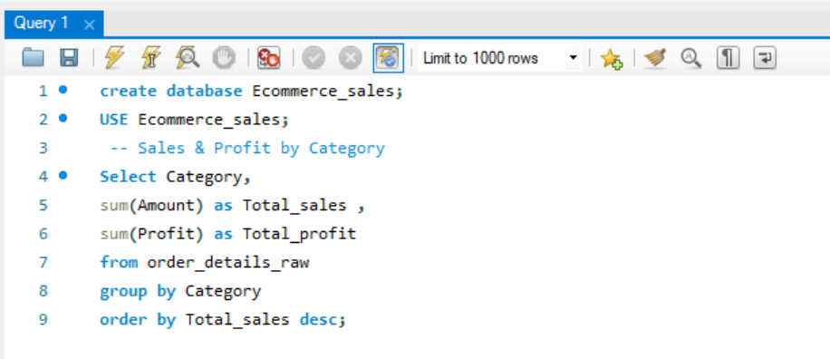**Queries** :

1. Sales and Profit by Category

Output :

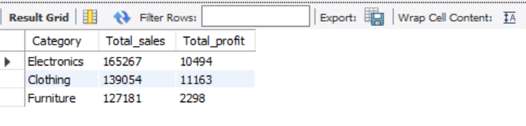

**Query Insights** : Electronics generated the highest total sales, followed by Furniture and Clothing. While Electronics contributed strongly to revenue, profit margins varied across categories. This suggests the business should focus on high-profit segments and optimize weaker ones.

1. 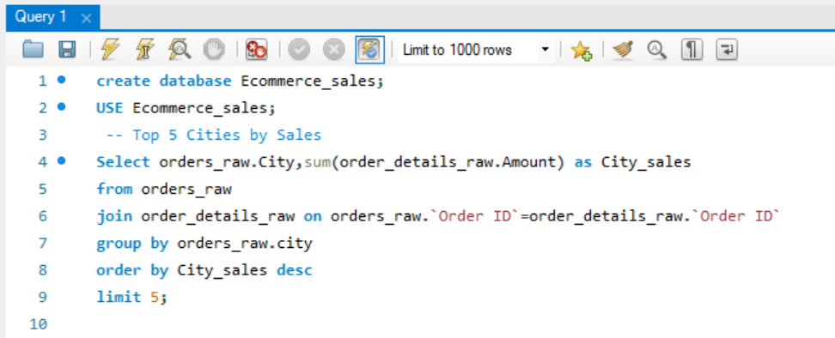Top 5 Cities by Sales

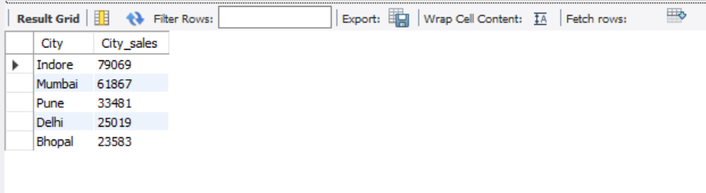

Output :

**Query Insights** : The top five cities contributed the largest share of total revenue. This shows that sales are **concentrated in a few regions**, making them key markets.The company can target promotions and inventory planning in these high-performing cities.

1. Sales vs Targets :

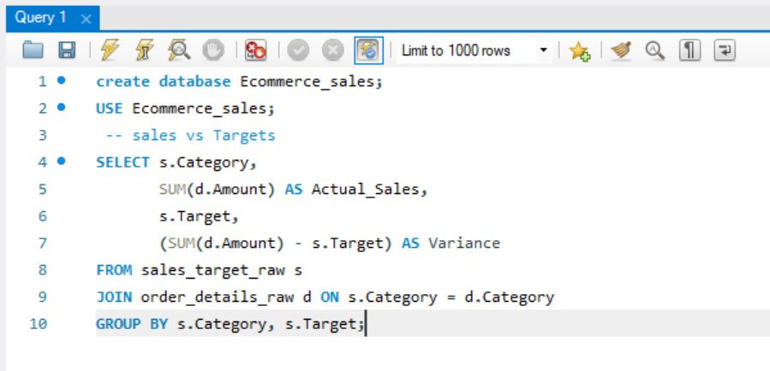

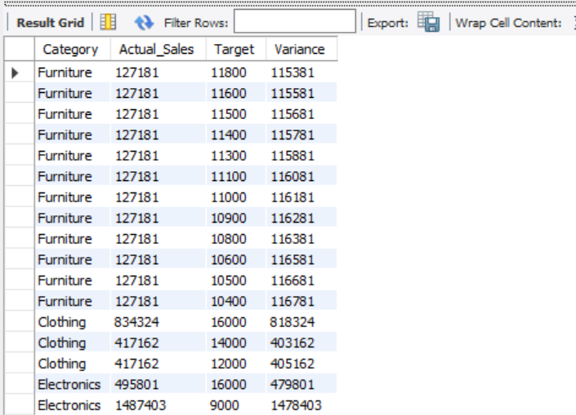Output :

**Query Insights** : Some categories exceeded their sales targets, while others fell short. This highlights areas of strong performance as well as **gaps that need attention**. Business managers can adjust marketing and strategy to improve underperforming categories.

1. 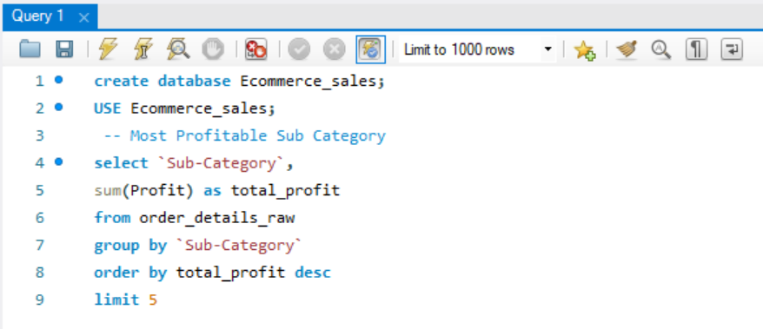Most Profitable Sub-Category :

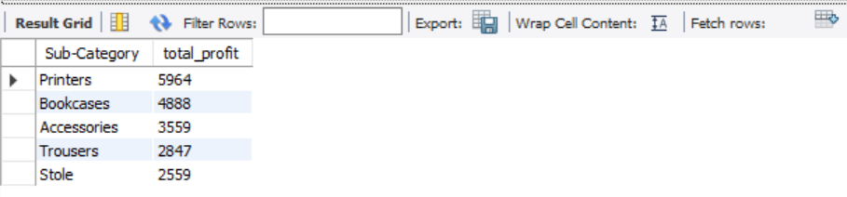Output :

**Query Insights** : A few sub-categories (like Smartphones and Laptops) brought the highest profits. These sub-categories are **critical drivers of profitability**. Low-profit sub-categories may require cost reduction or product review.

1. Top 5 Customers

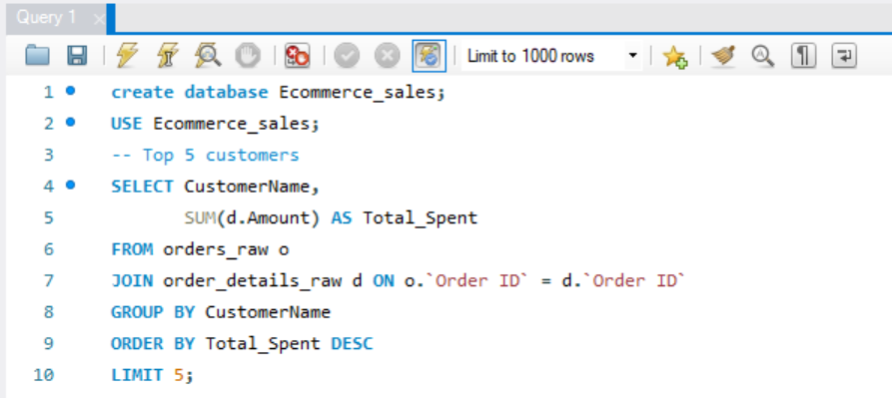

 Output :

**Conclusion** :

The Ecommerce sales analysis of a **real-world dataset** provides clear insights into business performance. Sales and profit by category helped identify the most profitable product lines. The top 5 cities and top 5 customers reveal the main revenue sources. Comparing actual sales against targets highlights over performing and underperforming categories. The most profitable sub-categories show which products drive the highest profit. Overall, this project demonstrates how SQL can support strategic decisions in e-commerce.

**Submitted By**

**M.Selvakumar**